Lake Wylie Mini Storage
5580 Highway 557, Lake Wylie, SC 29710
803-831-8031
(Beside Bethel Volunteer Fire Department and Oak Ridge Middle School)

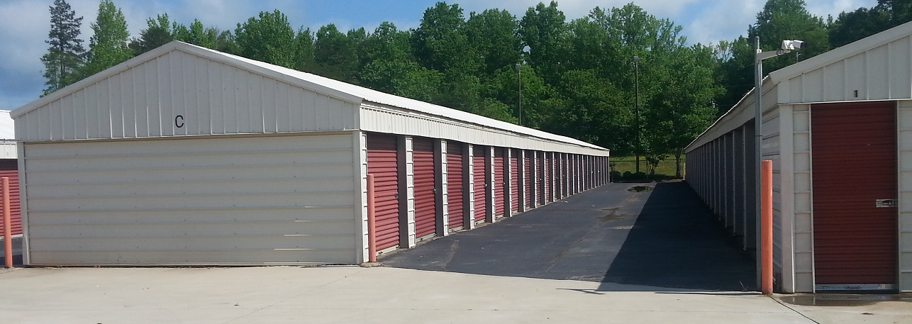
Storage Units Completely fenced in perimeter
5 x 10 - $50 24 hour security key pad entry
10 x 10 - $75 24 hour security camera surveillance
10 x 20 - $100
Outside Storage Available
Under 20’ - $50
Over 20’ - $50 plus $1 Per foot.

ours
Monday thru Friday – 9 am to 5 pm Saturday – 9 am to 1 pm
*Closed each day from 12 to 1 for lunch
Office Hours
Monday thru Friday – 9 am to 5 pm Saturday – 9 am to 1 pm
*Closed each day from 12 to 1 for lunch
Office Hours
Monday thru Friday – 9 am to 5 pm Saturday – 9 am to 1 pm
*Closed each day from 12 to 1 for lunch

Office Rentals
Office Hours
Monday thru Friday – 9 am to 5 pm Saturday – 9 am to 1 pm
*Closed each day from 12 to 1 for lunch

- 24 hour access
- Security monitoring

